**Task 6-Gemini**

**Styling Text and Fonts with CSS**

CSS offers a wide range of properties to control the appearance of text on web pages. Here are some common properties and an example demonstrating their usage:

**Properties**

* **font-family:** Specifies the font to be used for the text.
* **font-size:** Sets the size of the text.
* **font-weight:** Controls the boldness of the text (e.g., normal, bold, bolder).
* **text-align:** Determines the horizontal alignment of the text (e.g., left, center, right).
* **color:** Sets the color of the text.
* **text-decoration:** Applies decorations to the text (e.g., underline, line-through).
* **text-transform:** Converts text to uppercase, lowercase, or capitalized.

**Example HTML Document with Styled Text**

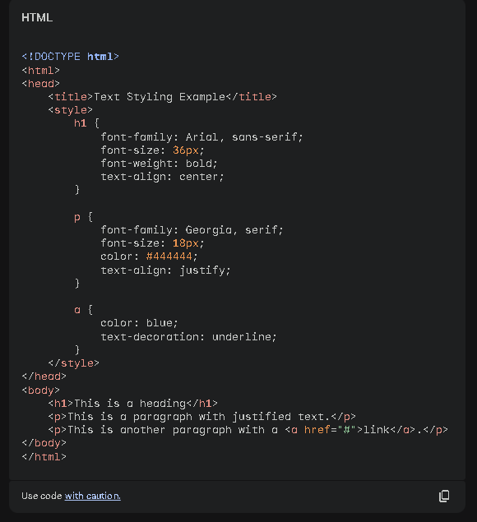

**Result:**

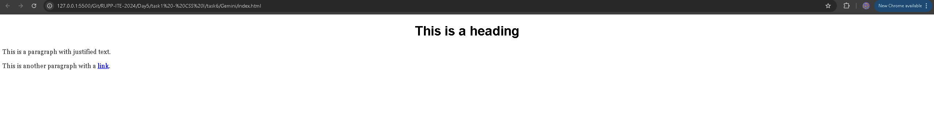

**Explanation of the Styles**

* **Heading:** The <h1> element uses the Arial font family, has a font size of 36 pixels, is bold, and is centered.
* **Paragraph:** The <p> elements use the Georgia font family, have a font size of 18 pixels, are a dark gray color, and have justified text alignment.
* **Link:** The <a> element has a blue color and an underline decoration.

By combining these properties, you can create a wide variety of text styles to match the design and content of your web pages.